
ASSIGNMENT 3

SPECIAL TOPICS IN COMPUTER SCIENCE

INFORMATION
NAME: ABDUL SAMI
REG: 8929
TO: Ma’am Sadaf tanvir

Forward Pass:
The forward pass is the step where a neural network takes an input and produces an output. The input moves layer by layer through the network. Each layer multiplies the input by its weights, adds a bias, and applies an activation function. The result becomes the next layer’s input until the final prediction is made. Simply, the forward pass is the network making a prediction using its current weights.
Forward pass is passing the input in the network layer by layer.

In the CNN code we made changes :
:only one CONV2D layer is used
:1 image dataset is used

Role of Forward pass in this code:

The forward pass is the step where the image goes through the model layer by layer to produce:
- Conv2D output
- MaxPool output
- Final softmax prediction
- Loss value
It is basically the model making a prediction.
In your code, the forward pass happens here:
- When you call the model with dummy input (to build it).
- Inside the GradientTape block (probe_model(images)), where you get conv, pool, and prediction outputs.
- During training (model.fit), for every batch.
Forward pass = the model calculating outputs from input.
It is required before backpropagation can compute gradients.

print("\n=== FORWARD VALUES ===")
stats("Before MaxPool (Conv2D output)", conv_out.numpy())
stats("After MaxPool (MaxPool output)", maxpool_out.numpy())

Backpropagation:
Backpropagation is the process where a neural network learns by adjusting its weights. After making a prediction, it calculates the error and then moves backward through the network to update each weight so the next prediction becomes better. In simple words, forward pass predicts, backpropagation corrects.
Key points
-> Calculates the error (loss)
-> Propagates this error back through the layers.
-> Computes gradients (∂Loss/∂Weights)
-> Updates the weights to minimize the error
CODE
print("=== PARAMETER VALUES BEFORE TRAINING ===")
for var in model.trainable_variables:
print(var.name, " → first weight:", float(var.numpy().flatten()[0]))

# Explicitly call the model with a dummy input to ensure it's built
# and its layers' output tensors are instantiated.
# The input_shape for build is equivalent to the input of the first layer
dummy_input_for_build = tf.zeros(shape=(1, 8, 8, 3))
_ = model(dummy_input_for_build)

# ---------- Backprop inspection block ----------
conv_layer = model.layers[1] # Conv2D
pool_layer = model.layers[2] # MaxPool

probe_model = tf.keras.Model(
inputs=model.inputs[0],
outputs=[conv_layer.output, pool_layer.output, model.layers[-1].output] # Changed model.output to model.layers[-1].output
)

def stats(name, t):
t = np.array(t)
print(f"{name} shape:{t.shape} min:{t.min():.6f} max:{t.max():.6f} mean:{t.mean():.6f}")

for images, labels in train_data.take(1):
images = tf.cast(images, tf.float32)
labels = tf.cast(labels, tf.int32)

with tf.GradientTape(persistent=True) as tape: # Made tape persistent
conv_out, maxpool_out, preds = probe_model(images, training=False)
loss = tf.reduce_mean(
tf.keras.losses.sparse_categorical_crossentropy(labels, preds)
)

tape.watch(conv_out)
tape.watch(maxpool_out)

grad_conv = tape.gradient(loss, conv_out)
grad_pool = tape.gradient(loss, maxpool_out)
grad_vars = tape.gradient(loss, model.trainable_variables)

del tape # Delete the persistent tape to free resources

print("\n=== FORWARD VALUES ===")
stats("Before MaxPool (Conv2D output)", conv_out.numpy())
stats("After MaxPool (MaxPool output)", maxpool_out.numpy())

print("\n=== BACKWARD GRADIENTS ===")
stats("Gradient dL/d(Conv2D output)", grad_conv.numpy())
stats("Gradient dL/d(MaxPool output)", grad_pool.numpy())

print("\n=== TRAINABLE VARIABLE GRADIENTS ===")
for var, g in zip(model.trainable_variables, grad_vars):
print(f"{var.name} grad shape:{g.shape} min:{tf.reduce_min(g):.6f} max:{tf.reduce_max(g):.6f}")
break
Roles in code:
Backpropagation is the process where the model learns by updating its weights.
- The model first does a forward pass to calculate predictions and loss.
- Then, backpropagation computes the gradients of the loss with respect to each weight.
- These gradients tell the model how much and in which direction to change each weight to reduce the loss.
In your code,
grad_vars = tape.gradient(loss, model.trainable_variables)
- tape.gradient calculates dL/d(weight) for every trainable variable.
- These gradients are then used by the optimizer (like Adam) to update weights during training.

Key points
- Forward pass → compute predictions and loss
- Backward pass → compute gradients
- Gradient descent → update weights
So backpropagation is the backward pass that enables learning

Gradient Descent:
Gradient descent is a method that updates weights by taking small steps in the direction that reduces the model’s error.

Key Points
- Finds the direction of lowest error
- Updates weights step-by-step
- Uses the gradient (slope) to guide movement
- Learning rate controls step size
- Goal: reach minimum error (best performance)
Role in code:
Gradient descent is the process of updating the model’s weights to reduce the loss.
- Backpropagation computes gradients (how much each weight affects the loss).
- Gradient descent moves each weight slightly in the opposite direction of its gradient.
  - This reduces the loss step by step.
- The learning rate controls how big each step is.

Code
print("=== PARAMETER VALUES BEFORE TRAINING ===")
for var in model.trainable_variables:
print(var.name, " → first weight:", float(var.numpy().flatten()[0]))

print("\n=== PARAMETER VALUES AFTER TRAINING ===")
for var in model.trainable_variables:
print(var.name, " → first weight:", float(var.numpy().flatten()[0]))

Modification
You modified the given code using:
Only 1 Conv2D layer
Layers: 1
Epochs: 1
Seed: 1
Dense layer input: 8 × 8 × 32
Conv2D: (8, 8, 2)
Batch size: 32
Image size: 8 × 8
You also created separate folders for each class (Disease & Healthy) in:
TRAIN-1
TEST-1
Output
Before normalization:

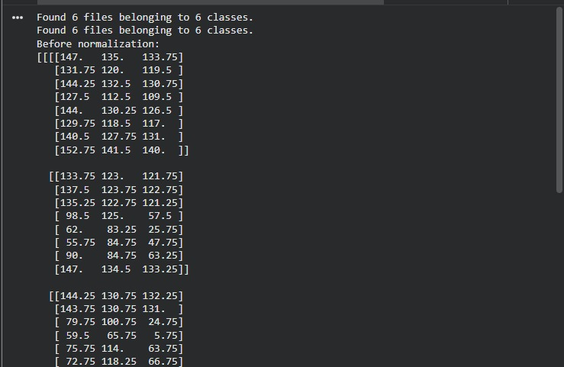

After normalization:
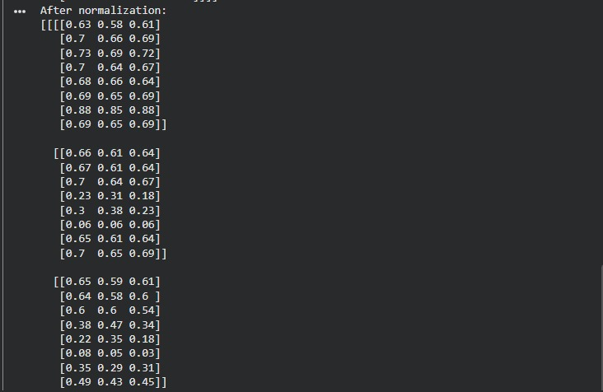

Before training:
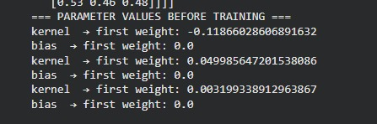

After training:
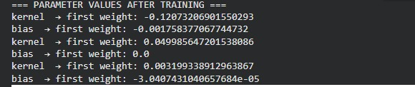

Backward Gradient:
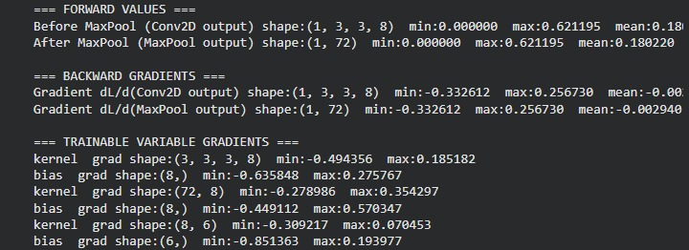
Before maxpooling:

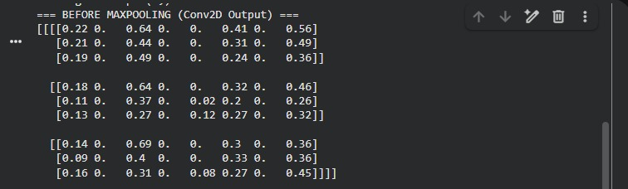

After maxpooling:

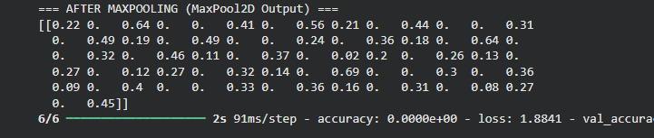
Grapgh:

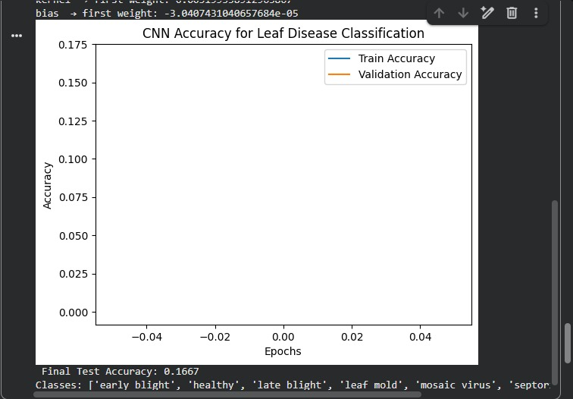

accuracy: 0.1667

